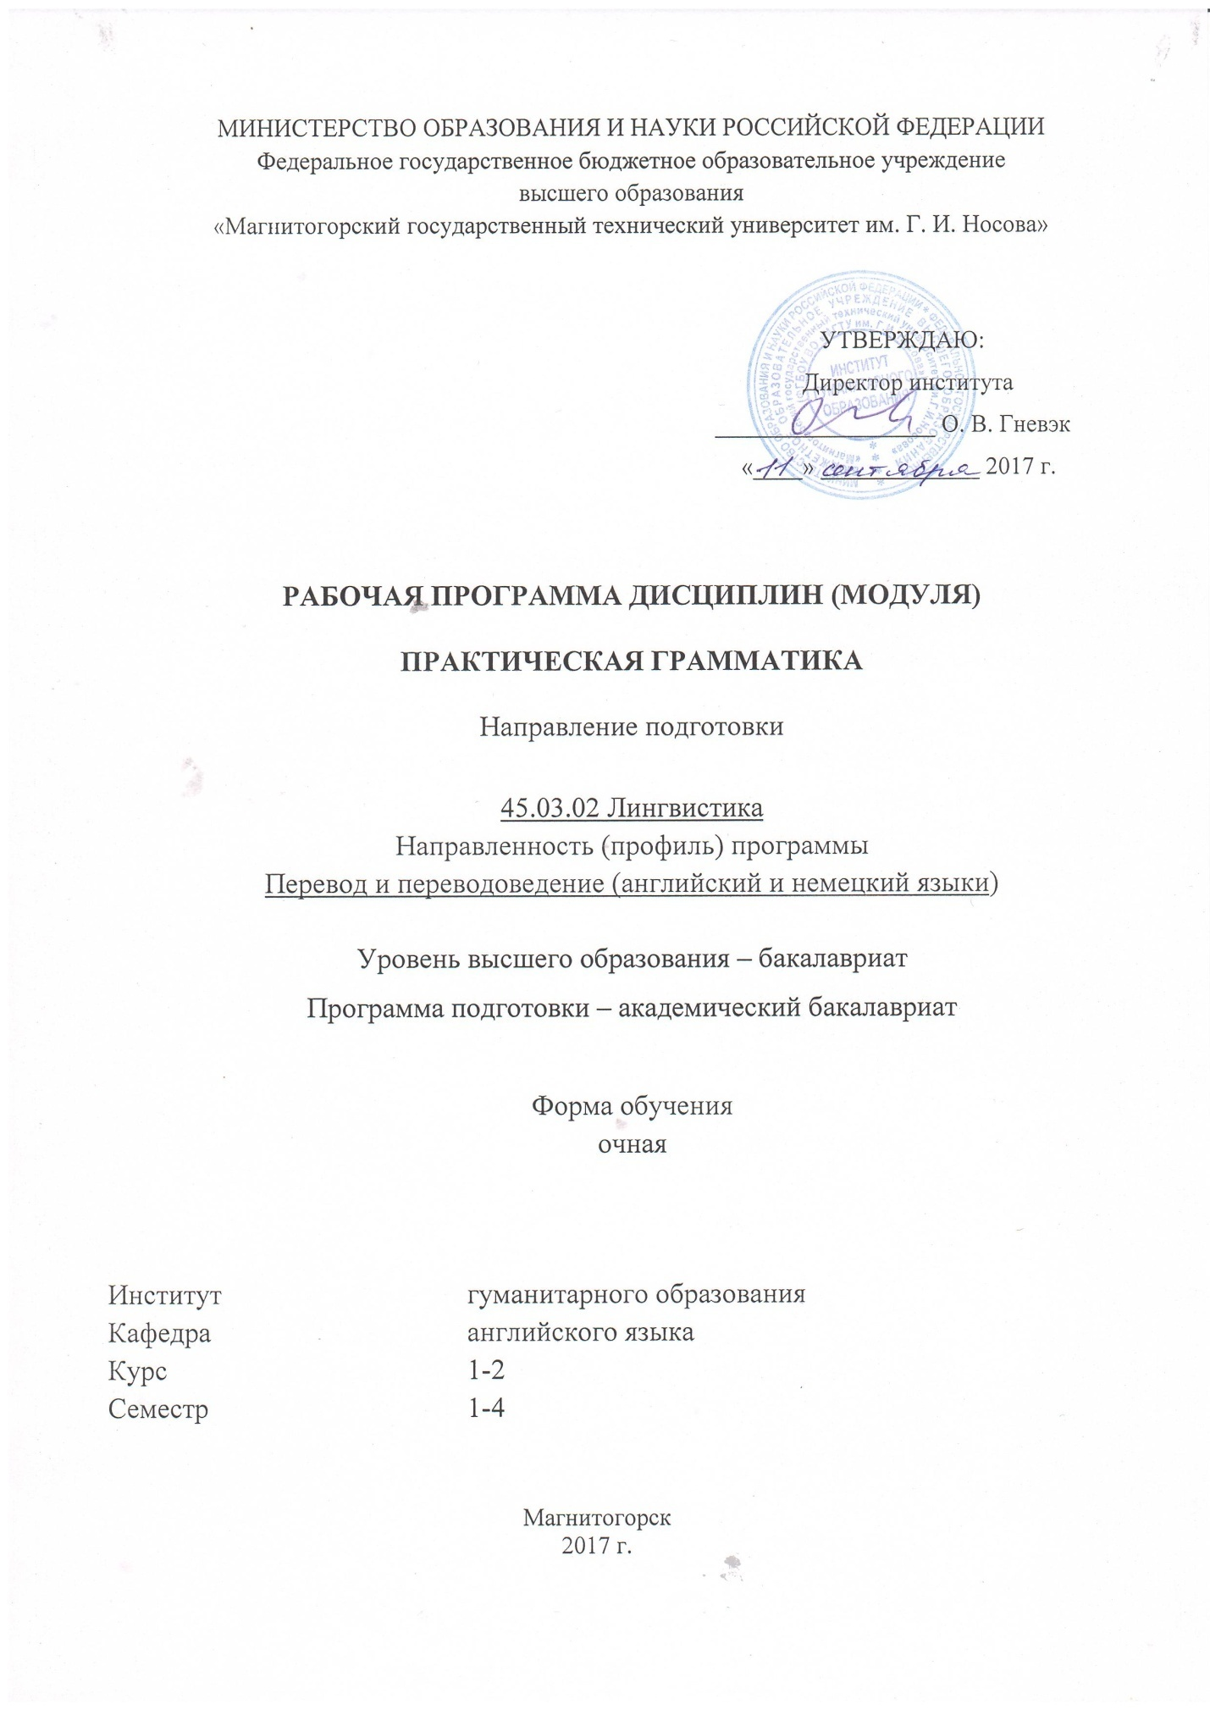

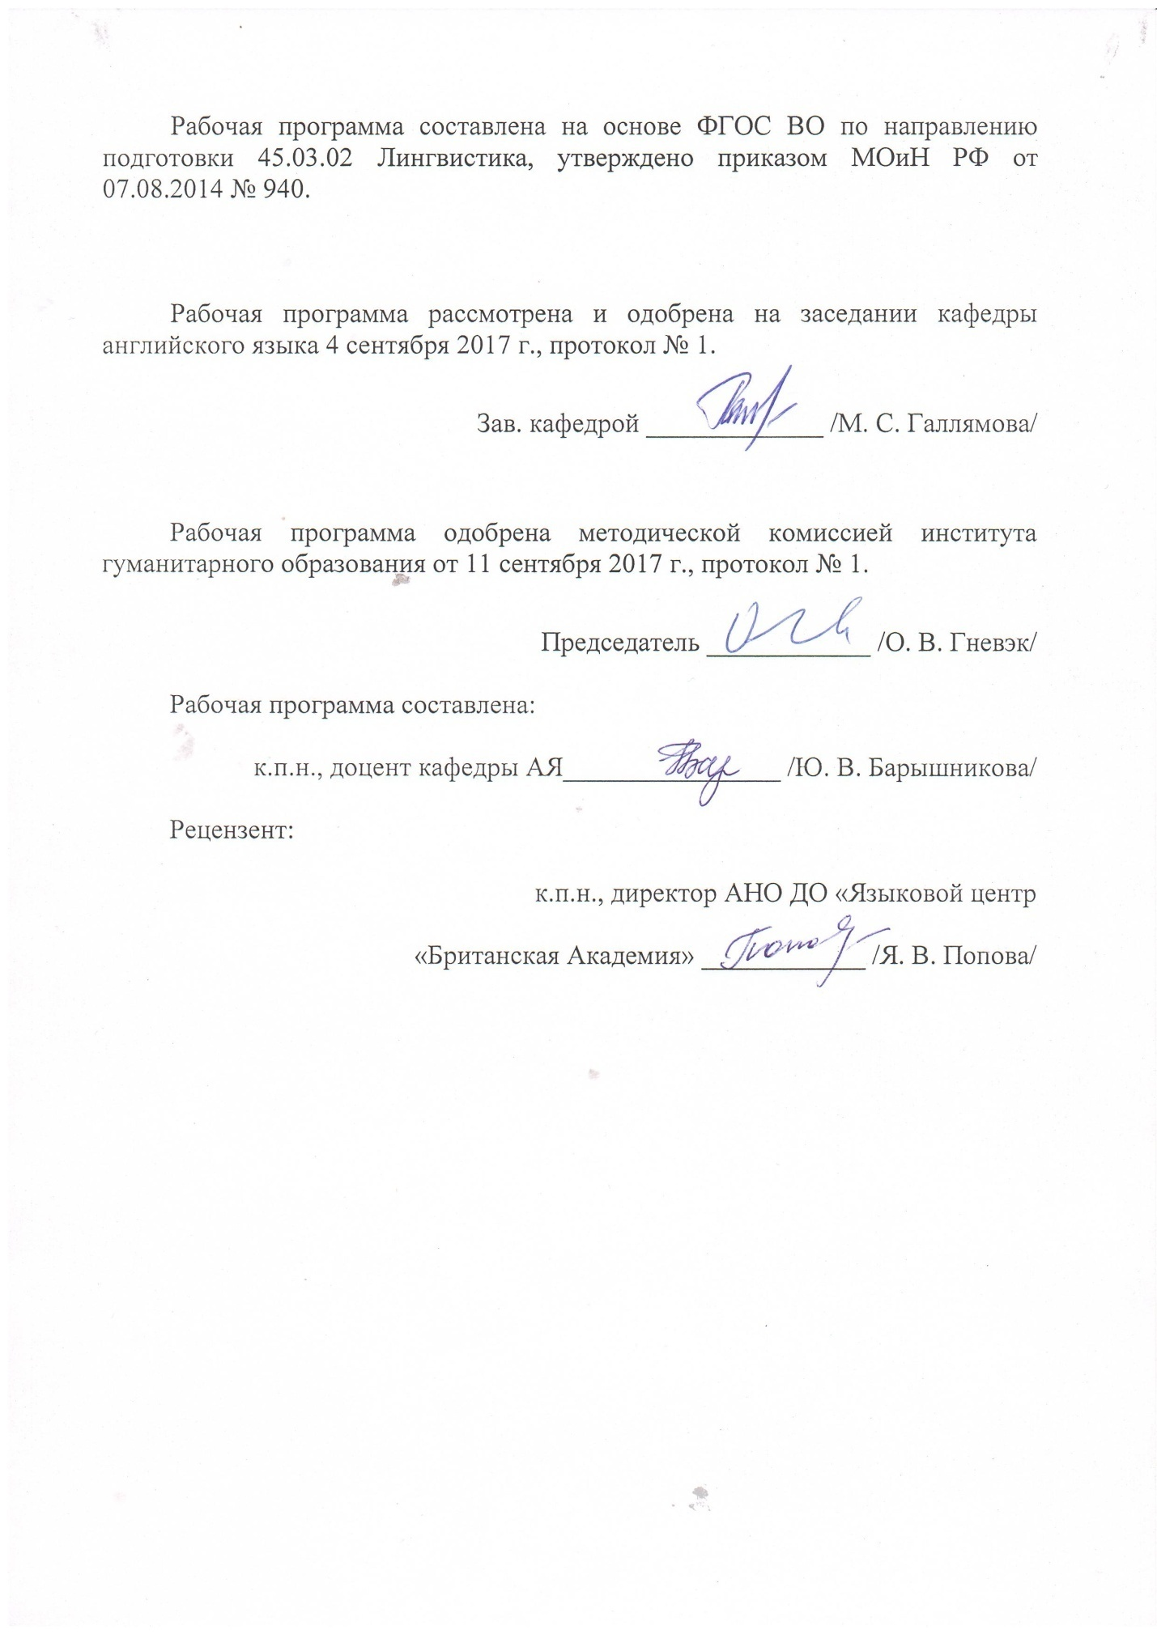

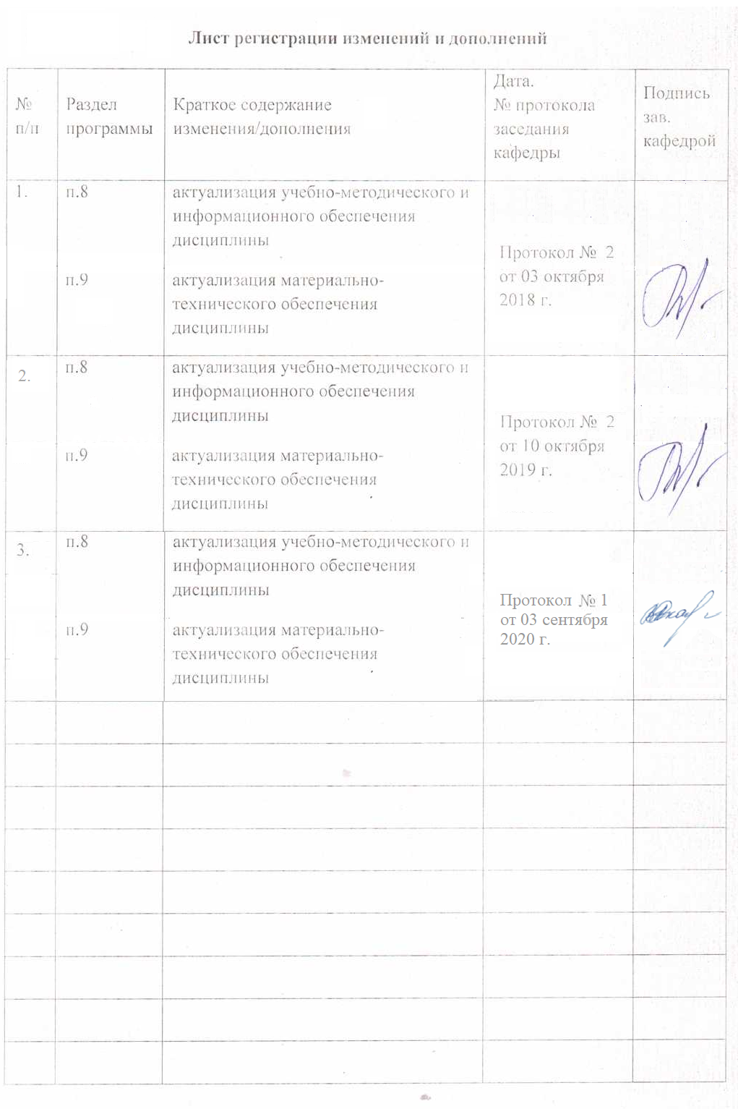

1 Цели освоения дисциплины (модуля)

# **Целями освоения дисциплины (модуля) являются:** изучение грамматического строя литературного английского языка и овладение навыками грамматически правильной речи в процессе межкультурной коммуникации, овладение умением распознавать в тексте и объяснять на иностранном языке суть основных грамматических явлений изучаемого языка; осуществлять синтаксический анализ простого и сложного предложений; делать устный перевод русских предложений на английский язык с применением необходимых грамматических конструкций.

Задачи:

- познакомить студентов с грамматической системой английского языка;

- сформировать у студентов необходимые речевые грамматические навыки, в основе которых лежат знания морфологии и синтаксиса английского языка;

- научить студентов использовать грамматические явления в речевых образцах.

# 2 Место дисциплины (модуля) в структуре образовательной программы подготовки магистра

Данная дисциплина является обязательной дисциплиной вариативной части в профессиональном блоке дисциплин Б1 в подготовке бакалавров по профилю «Перевод и переводоведение (Английский и немецкий языки)» по направлению подготовки «Лингвистика». Дисциплина «Практическая грамматика» изучается на 1, 2 курсах (1, 2, 3, 4 семестры).

Для изучения дисциплины необходимы знания(умения, навыки), грамматических норм английского языка на уровне Б1 (пороговый уровень), а именно:

- знание языковых средств общения в предусмотренных программой рамках;

- знание грамматических явлений и наличие навыков их употребления в речи;

- владение рациональными приемами умственного труда, обеспечивающими культуру усвоения языка в учебных условиях и культуру общения с его носителями.

Знания (умения, владения), полученные при изучении данной дисциплины будут необходимы для изучения такихдисциплин, как «Практикум по культуре речевого общения (первый иностранный язык)», «Теоретическая грамматика».

# 3 Компетенции обучающегося, формируемые в результате освоения дисциплины (модуля) и планируемые результаты обучения

В результате освоения дисциплины (модуля) «Практическая грамматика» обучающийся должен обладать следующими компетенциями:

| Структурный  элемент  компетенции | Планируемые результаты обучения |
| --- | --- |
| **ОПК-3**владением системой лингвистических знаний, включающей в себя знание основных фонетических, лексических, грамматических, словообразовательных явлений и закономерностей функционирования изучаемого иностранного языка, его функциональных разновидностей | |
| Знать | * систему лингвистических знаний, включающую в себя знание основных фонетических, лексических, грамматических, словообразовательных явлений и закономерностей функционирования изучаемого иностранного языка, его функциональных разновидностей |
| Уметь | * применять систему лингвистических знаний,включающую в себя знание основных фонетических, лексических, грамматических, словообразовательных явлений и закономерностей функционирования изучаемого иностранного языка, его функциональных разновидностейв профессиональной деятельности; использовать ее на междисциплинарном уровне; |
| Владеть | * системой лингвистических знаний, включающей в себя знание основных фонетических, лексических, грамматических, словообразовательных явлений и закономерностей функционирования изучаемого иностранного языка, его функциональных разновидностей |
| **ОПК-5**владением основными дискурсивными способами реализации коммуникативных целей высказывания применительно к особенностям текущего коммуникативного контекста | |
| Знать | * основные дискурсивные способы реализации коммуникативных целей высказывания применительно к особенностям текущего коммуникативного контекста |
| Уметь | * применять на практике основные дискурсивные способы реализации коммуникативных целей высказывания применительно к особенностям текущего коммуникативного контекста |
| Владеть | * практическими навыками использования основных дискурсивных способов реализации коммуникативных целей высказывания применительно к особенностям текущего коммуникативного контекста |
| **ОПК-6**владением основными способами выражения семантической, коммуникативной и структурной преемственности между частями высказывания - композиционными элементами текста | |
| Знать | * основные способы выражения семантической, коммуникативной и структурной преемственности между частями высказывания - композиционными элементами текста |
| Уметь | * применять на практике основные способы выражения семантической, коммуникативной и структурной преемственности между частями высказывания - композиционными элементами текста |
| Владеть | * практическими навыкамииспользования основных способов выражения семантической, коммуникативной и структурной преемственности между частями высказывания - композиционными элементами текста |
| **ОПК -7**способностью свободно выражать свои мысли, адекватно используя разнообразные языковые средства с целью выделения релевантной информации | |
| Знать | * разнообразные языковые средства с целью выделения релевантной информации |
| Уметь | * применятьразнообразные языковые средства с целью выделения релевантной информации |
| Владеть | * практическими навыками свободно выражать свои мысли, адекватно используя разнообразные языковые средства с целью выделения релевантной информации |
| **ПК-7**владением методикой предпереводческого анализа текста, способствующей точному восприятию исходного высказывания | |
| Знать | * методику предпереводческого анализа текста, способствующей точному восприятию исходного высказывания |
| Уметь | * применять методику предпереводческого анализа текста, способствующей точному восприятию исходного высказывания |
| Владеть | * практическими навыками использования методики предпереводческого анализа текста, способствующей точному восприятию исходного высказывания |

# **4 Структура и содержание дисциплины (модуля)**

Общая трудоемкость дисциплины составляет 10 зачётных единиц,360 часов:

– аудиторная работа – 105 часов;

- внеаудиторная работа –4,8 часов

– самостоятельная работа –178,8 часов;

– подготовка к экзамену –71,4 часа.

| Раздел/ тема  дисциплины | Семестр | Виды учебной работы,  включая самостоятельную работу студентов и трудоемкость (в часах) | | | | Формы текущего и  промежуточного  контроля успеваемости | Код и структурный  элемент компетенции |
| --- | --- | --- | --- | --- | --- | --- | --- |
| лекции | лаборат.  занятия | практич. занятия | самост.  раб. |
| **1. Раздел Morphology** |  |  |  |  |  |  |  |
| **1.1.ТемаThe Noun:**  classification of nouns;countable and uncountable nouns; morphological analysis of the noun;the category of number, the category of case. | 1 |  |  | 9/4 | 8,9 | Грамматическиетесты. Контрольныеработы. | ОПК-3-зув  ОПК-5-зув  ОПК-6-зув  ОПК-7-зув |
| **1.2. ТемаThe Article:** indefinite article;  the definite article;  theabsence of article. | 1 |  |  | 9/4 | 9 | Грамматическиетесты. Контрольные работы. | ОПК-3-зув  ОПК-5-зув  ОПК-6-зув  ОПК-7-зув |
| **1.3. ТемаThe Verb:**  morphological analysis of the verb;the category of tense, aspect, voice, mood. | 1 |  |  | 9/4 | 9 | Грамматическиетесты. Контрольныеработы. | ОПК-3-зув  ОПК-5-зув  ОПК-6-зув  ОПК-7-зув |
| **1.4. ТемаThe Pronoun:**  morphological analysis of the pronoun;types of pronouns;  personal pronouns;the category of case, number, gender, person. | 1 |  |  | 9/2 | 9 | Грамматическиетесты. Контрольные работы. | ОПК-3-зув  ОПК-5-зув  ОПК-6-зув  ОПК-7-зув |
| **Итого по разделу** | 1 |  |  | **36/14** | **35,9** | **Зачёт** |  |
| **2. Раздел Morphology** | 2 |  |  |  |  |  |  |
| **2.1. Тема The Verb:**  reported speech;tense forms: revision;  uses of the subjunctive mood; modal verbs. | 2 |  |  | 10/4 | 12 | Грамматическиетесты. Контрольные работы. | ОПК-3-зув  ОПК-5-зув  ОПК-6-зув  ОПК-7-зув |
| **2.2. Тема The Adjective:**  relative and qualitative adjectives;comparison of adjectives; irregular comparison of adjectives; predicate adjectives; nouns used as adjectives. | 2 |  |  | 9/4 | 9,9 | Грамматическиетесты. Контрольные работы. | ОПК-3-зув  ОПК-5-зув  ОПК-6-зув  ОПК-7-зув |
| **2.3. ТемаThe Adverb:**  Form of adverbs; interrogative adverbs; adverbs of degree; comparison of adverbs; irregular comparison of adverbs.  qualifying and circumstantial adverbs;degrees of comparison. | 3 |  |  | 9/4 | 8 | Грамматическиетесты. Контрольные работы. | ОПК-3-зув  ОПК-5-зув  ОПК-6-зув  ОПК-7-зув |
| **2.4. ТемаThe Pronoun:**  Agreement of pronoun and antecedent in gender; agreement of pronoun with a compound antecedent; determiners and quantifiers. | 2 |  |  | 6/2 | 8 | Тест. | ОПК-3-зув  ОПК-5-зув  ОПК-6-зув  ОПК-7-зув |
| **Итого по разделу** | **2** |  |  | **34/14** | **37,9** | **Зачёт** | ОПК-3-зув  ОПК-5-зув  ОПК-6-зув  ОПК-7-зув |
| **Итого за курс** |  |  |  | **70.28** | **73,8** |  |  |
| **3.Раздел Morphology** | 3 |  |  |  |  |  |  |
| **3.1.ТемаThe Infinitive:**  nature of the infinitives;  morphological analysis of the infinitive;the category of aspect, relative tense, voice;for-to infinitive constructions;the accusative with the infinitive;the nominative with the infinitive; the infinitive phrase;  functions of the infinitive in the sentence. | 3 |  |  | 6/2 | 17 | Грамматическиетесты. Контрольные работы. | ОПК-3-зув  ОПК-5-зув  ОПК-6-зув  ОПК-7-зув |
| **3.2.ТемаThe Participle:**  forms of the Participle;the accusative with the participle; dangling participles;the nominative with the participle;  nominative absolute participle constructions;functions of the participle in the sentence. | 3 |  |  | 6/2 | 17 | Грамматическиетесты. Контрольные работы. | ОПК-3-зув  ОПК-5-зув  ОПК-6-зув  ОПК-7-зув |
| **3.3. ТемаThe Gerund:**  nature of the gerund; morphological analysis of the gerund;the category of relative tense and voice;gerundial complexes; the dangling gerund; functions of the gerund in the sentence. | 3 |  |  | 6/2 | 18 | Грамматическиетесты. Контрольные работы. | ОПК-3-зув  ОПК-5-зув  ОПК-6-зув  ОПК-7-зув |
| **Итого по разделу** | 3 |  |  | **18/6** | **52** | **Экзамен** |  |
| **4. Раздел Syntax** | 4 |  |  |  |  |  |  |
| **4.1. Тема The Subject:**  notional and formal subject;  introductory “it” and “there” subjects; the simple subject; the compound subject | 4 |  |  | 4/2 | 13 | Грамматическиетесты. Контрольные работы. | ОПК-3-зув  ОПК-5-зув  ОПК-6-зув  ОПК-7-зув |
| **4.2. ТемаThe Predicate:**  simple and compound predicates;simple verbal and nominal predicates;compound verbal modal predicate;compound verbal phrasal predicate; compound verbal predicate of double orientation;  compound nominal predicate proper;compound nominal double predicate;mixed types of predicates. | 4 |  |  | 4/2 | 13 | Грамматическиетесты. Контрольные работы. | ОПК-3-зув  ОПК-5-зув  ОПК-6-зув  ОПК-7-зув |
| **4.3. ТемаAgreement of the subject and the predicate:**  Agreement in person and number; agreement of the predicate with the compound subject; agreement of the predicate with collective nouns; agreement of the predicate with indefinite pronouns; special cases of agreement. | 4 |  |  | 5/2 | 14 | Грамматическиетесты. Контрольные работы. | ОПК-3-зув  ОПК-5-зув  ОПК-6-зув  ОПК-7-зув |
| **4.4. ТемаKinds of sentences:**  Invertedorder; interrogative sentence patterns; exclamatory and imperative sentence patterns; simple sentences; compound sentences; complex sentences. | 4 |  |  | 4/2 | 13 | Грамматическиетесты. Контрольные работы. | ОПК-3-зув  ОПК-5-зув  ОПК-6-зув  ОПК-7-зув |
| **Итого по разделу** |  |  |  | **17**/6 | **53** |  |  |
| **Итого по курсу** |  |  |  | **35/12** | **105** |  |  |
| **Итого по дисциплине** |  |  |  | **105**/**40** | **178,8** | **Экзамен** |  |

# 5 Образовательные и информационные технологии

В процессе реализации дисциплины «Практическая грамматика» используются технологии интегрированного обучения: технологии коммуникативного обучения, технологии тестирования, технологии развития критического и рефлексивного мышления.

В процессе реализации дисциплины используются следующие образовательный технологии: “ casestudies”, ролевые игры, проблемные задачи, межкультурные тренинги, ИКТ.

# 6 Учебно-методическое обеспечение самостоятельной работы обучающихся

По дисциплине«Практическая грамматика» предусмотрена аудиторная и внеаудиторная самостоятельная работа обучающихся.

1Раздел: Morphology (1)

Теоретическиевопросы:

1) What is the grammatical meaning of the noun?

2) What grammatical categories does the noun in English have?

3) What are the main classes of pronouns in English?

4) What grammatical categories does the English adjective have?

5) What is the main function of the article?

6) What grammatical categories does the verb in English have?

Практическиеупражнения:

1. Use the proper article:

1. __ flowers you bought me are lovely.

2. “Have you seen my socks?’ ‘You left them on ___ bed.

3. She usually stays in ___ bed till late at __ weekend.

4. Jim’s been in__ hospital for six weeks now.

5. I enjoy __ modern music.

6. I always like getting __ good news.

7. We had __ time on __holiday.

8. My brother is looking for __ job.

9. You have made __ great progress in your studies.

10. Did you have __ good weather on your trip?

11. I prefer __ to __ coffee.

12. In Sweden __children start __school when they are six or seven.

13. There is __hot and cold running water in all the bedrooms.

14. All my kids are still at __ school.

15. I cleaned __ car yesterday.

16. What __lovely scenery!

17. What is __longest river in __the world?

18. We had __dinner in a restaurant.

19. What __lovely dress!

20. I watched __news on__ television.

21. The motorcyclist was in __critical condition in __hospital last night.

22. __ tulips are my favourite flowers.

23. Do you like __ strong black coffee?

24. That was __lovely breakfast.

25. __river Nile has played __important role in __history of __ancient Egypt.

26. __doctors are paid more than __teachers.

27. There isn’t __hospital in __town.

28. _World War II ended in 1945.

29. __Isle of Wight is __largest island in __England.

30. __Fifth Avenue is among __most expensive streets in the world.

2 Write the indefinite article before the nouns which are being used as countable nouns

1. __Beauty is subjective. She is __real beauty.

2. I’m fortunate to have had _ very good education. __education does not just take place at school.

3. My eyes are very sensitive to __light.. Is there __ light in there?

4. You have been __great help to me. I’m sorry to ask but I desperately need __help.

5. I don’t usually drink _ coffee. I’ll have two teas and __ coffee.

6. He has __great love of music. Sometimes __love can be very painful.

7.You’ll get better at the job as you gain __ experience.

8. The house is built of __stone. This is __ beautiful stone.

9. __death comes to us all one day. There has been __ death in the family.

10. __fear is a perfectly natural human feeling. He has __terrible fear of heights.

11. I think that’s __ really ugly painting. __painting can be a very relaxing activity.

12. I usually eat __fruit for breakfast. That’s __very unusual fruit.

13. You should not drink __ wine on an empty stomach. This is __ very nice wine.

14. Would you like __baked potato? Has this soup got _ potato in it?

3 Open the brackets using the correct tense form.

1. Each July we (to go) to Turkey for a holiday.

2. The growing number of visitors (to damage) footpaths.

3. Jane (to leave) just a few minutes ago.

4. Timson (to make) 13 films and I think her latest is the best.

5. (To see) Robert lately?

6. When I was a child I (to play) the violin.

7. I (to read) until midnight last night.

8. He (to play) for the national team in 65 matches so far.

9. Sorry, we are late. We (to take) the wrong turning.

10. She (to suffer) from flu when she was interviewed.

11. Wait here until I (to call) you.

12. I won’t be able to meet you next week, I (to stay) in Moscow for a few days.

13. Next month I (to know) Derek for twenty years.

14. I (to write ) 3 letters this morning (The morning is over).

15.We (to have) the car for five years. (We no longer have it).

16. They have grown such a lot since we last (to see) them.

17. She dropped her bag while she (to get) into her car.

18. Your eyes are red – you (to cry)?

19. I always (to admire) Chester’s work.

20. I (to want) to visit the gallery before I left Florence, but it is closed on Sundays.

2Раздел: Morphology (2)

Теоретическиевопросы:

1) What does the Active voice denote?

2) What does the Passive voice denote?

3) What syntactical /analytical forms of the Subjunctive mood are used in Modern English?

4) What are modal verbs in English?

Практическиеупражнения:

1) Open brackets using Conditionals 2 and 3:

1. If someone (to tell) me ten years ago that this was the future I (to laugh). 2. It (not to surprise) him if she (to be) angry or (to make) a scene, or if she (to cry); he (can, to cope) with that; but her calmness frightened him. 3. I wish I could go to Italy now. The peasants (to call) me “Don” and (to take off) their hats if I (to meet) them. I (to go) hunting through the chestnut woods. The peasants (to be) honoured if I (to eat) at their houses. 4. He (to be) dead in a week if he (to see) everyone who wants to see him. 5. It (to be) a bad world if you (not to get) a good laugh now and then. 6. It’s a chance in a thousand, and I think it (to be) madness if you (not to take) it. 7. She realized that it (to be) a bitter blow to his pride if he ever (to have) an inkling how little he meant to her. 8. If I (to be) in your place, I probably (to do) the same thing.

2) Translate into English using *wish* and *as if/as though*:

1. Жаль, что Боб не может обеспечивать семью. Иначе бы он немедленно женился. 2. Как бы мне хотелось побывать в Париже, но, боюсь, это неосуществимая мечта. 3. Я бы хотела ответить на ваши вопросы, но ноше время истекло. 4. Жаль, что наш план провалился. 5. Он бежал так быстро, как будто за ним кто-то гонится (tochase). 6. Ваш сын так хорошо говорит по-английски, как будто всю жизнь провел в Англии. 7. По вашим словам получается (Yousound), что вы замечательно провели время на вечеринке. А мне сказали, что вы не провели там и часа. 8. Она выглядела свежей и отдохнувшей, словно не провела бессонную ночь в аэропорту.

3) Complete the following sentences with the correct form of *can, could or be able*. If it is possible to use *can| could or be able*, use *can|could..*

1 He is very fit for his age. He ____(run) really fast.

2 I’d like __ (work) with you one day.

3 He ______(not climb) up to the top: he was too scared.

4 If they hadn’t phoned for an ambulance, he _____(die).

5 I love ____(spend) all morning in bed at the weekends.

6 We ______(go) to that concert tomorrow if the tickets haven’t sold out.

7 I think you should go in the spring: it ____(be) very crowded there in the summer.

8 I ___(not understand) what he says: he speaks too quickly.

9 Do you know where Nick’s glasses are? He ____ (not see) very much without them.

10 _______speak another language fluently is a great advantage when you’re looking for a job.

11 Jonathan ____(not say) anything until he was about three years old.

12 We ___(not phone her up) because her phone had broken, but fortunately we ___(get) a message to her.

13 Amy’s exam results weren’t very good. She ___ (do) better.

14 I ___ (not sleep) very well for the last four nights. It’s been too hot.

15 She tried to think of other things but she ____ (not put) that awful memory out of her mind.

16 You should ______ (go out) when you want to.

17 _____(you come) to the party on Saturday?

3Раздел: Morphology (3)

Теоретическиевопросы:

1) What are non-finite forms of the English Verb?

2) What nominal and verbal features does the English Infinitive have?

3) What nominal and verbal features does the English Gerund have?

4) What features do Participle I and II possess?

5) What are complexes with verbal in English?

Практическиеупражнения:

1) Open the brackets

1. He bitterly resents (treat) like a child.

2. I remember (go) to the British Museum one day to read up the treatment for some slight ailment.

3. We’re considering (buy) a new car.

4. I don’t envisage (work) with him again.

5. I used (think) she’d love to marry me.

6. My job involves (travel) a lot.

7. We regret (inform) you that your application has not been successful.

8. Now I regret (not get) education.

9. I can still vividly remember my grandfather (teach)me (play) chess.

10. I’d advise you (keep) to a diet of fruit and vegetables.

11. Remember (call) me when you arrive.

12. I’d advise you (read) the instructions first.

13. I recommend (drink) plenty of liquids.

14. We are really looking forward (see) you again.

15. She must be made (follow) the rules.

16. They knew they risked (arrest).

17. They have been advised not to risk (travel) in these conditions.

18. He keeps (put off) (go) to the dentist.

19. Remember (put) the clock forward tonight (because the time has officially changed).

20. How did you manage (persuade) him?

21. She hesitated before (reply).

22. The new schedule will mean (work) overtime.

2) Comment on the form of the Verbal. State the syntactic function of the Verbal. Point out the syntactic complexes with the Infinitive.

1. She lifted the flowers and let them drop again, and they fell into another orderly pattern.

2. My job is not teaching you manners.

3. She can’t stand being contradicted.

4. She washed her face and combed out the tangles in her hair before going downstairs again.

5. Of course I’ll go. I’d go any place if there is the slightest chance of getting this job.

6. He proved to be their devoted friend.

7. He waited impatiently for Eliza to go on.

8. She found no one to admire.

9. There is some information I want you to obtain.

10. Gertrude wanted to surprise her guests with European food.

3) Open the brackets. Use the Verbals in the appropriate form. Add prepositions where necessary:

1. We felt the ground (to rock and tremble) under our feet.

2. There is no (to reason) with her.

3. The poems are believed (to write) by a young woman.

4. How can I do it without somebody (to notice me) and (to begin) to ask questions?

5. She is not likely (to forget) her promise.

6. Can I learn to speak better (to listen) to records?

7. He is far too lazy (to do) it himself.

8. Are you really thinking (to give up) this job?

9. So much depends (he to be) the right man for the job.

10. I see no harm (he to play) football.

4) Replace the parts in bold type by the nominative absolute construction.

1 Angie was coming easily down the steep slope. **Buck was close behind her.**

2 She rolled over on her front and lay motionless. **Her face was hidden in the curve of her arm.**

3 She was a charming healthy child of eight**. Her long arms and legs were already tanned to a lovely golden brown.**

4 A few more steps and she disappeared behind some dusty shrubs. **She was still holding the little dog in her arms.**

**5 Her face was pale, her smile listless.** She looked a different girl.

6 Madame came out of her office, smiling and bowing**. Her black silk dress was buttoned up over corsets three sizes too small for comfort**.

7 Even MrBolham went out at the sound of her office. **The unread newspaper was still in his hand.**

8 Mary sat leaning forward watching the fireworks. **Mary’s arm was round her shoulders.**

9 How can you expect me to do any work w**hen the children are making so much noise?**

10 He spent the rest of the journey in a screwed-up and uncomfortable position**. The massive knees of Mrs Gush were pressing into him at every jolt.**

4Раздел: Syntax (1)

Теоретическиевопросы:

1) What is the introductory subject?

2) What parts of speech can function as the subject in English?

3) What is the predicate?

4) What is the simple predicate?

5) How many kinds of compounds predicates are there in English?

Практическиеупражнения:

1) Point out the subject in the following sentences and state what it is expressed by. Translate into Russian.

1. You couldn’t define it more precisely! 2. It never rains, but it pours! 3. Two plus two makes four. 4. There was a tall lamp-post beside the packing house. 5. What is the meaning of all this? 6. A few more of these is all that is needed. 7. People don’t easily recognize their faults. 8. Dark blue is not your colour for a costume. 9. Who will be the second in command? 10. Which of them is the President? 11. To be or not to be, that is the question. 12. Smoking is not allowed. 13. One can’t be too sure. 14. How much do they offer? 15. They say it’s about ten miles from here. 16. The third may be not taken into account. 17. Your “i” must be dotted. 18. Will half of the sum be enough? 19. The brave won’t lay down their arms. 20. Never is a long time. 21. Here is a brighter torch for Jim.

2) Point out the predicate in each of the following sentences and state its type. Translate into Russian.

a) 1. He excused himself and went outside. 2. There came a surprise. 3. He wondered what she was thinking. 4. No questions were asked about his absence. 5. On steam tables the day’s dinner menu dishes were being portioned and served for delivery to dining-rooms. 6. I shouldn’t have allowed that to happen, believe me, my dear Eliot, if I had been there. 7. At dawn fighting broke out with renewed violence.

b) 1. But I must be going now. 2, “Why should we go down to dessert twice a day?’’ said Venice. 3. You will have to do as you were told. 4. Most of our senior officers will have arrived by then. 5. Your mother must have gone through a good deal of suffering. 6. They may have telephone communication. 7. Who could have done such a thing? 8. Jack ought to have stayed for tea with them.

c) 1. The man grinned from ear to ear and began to play a lively tune. 2 .1 kept walking, busy with my thoughts. 3. Aloysius Royce continued to work quietly as the other two talked. 4. He burst out laughing. 5. They ceased to speak eyeing the newcomer suspiciously. 6. He would go there every afternoon just for pleasure. 7. You remind me of someone I used to know from Africa. 8. She stopped to talk to the Cypriot tailor.

d) 1. Let the medical officer know, with my compliments, that I wish to see him. 2 .1 longed to go where there was life and movement. 3. The party director replied patiently, “I’d still prefer to come to your house.” 4. We decided to telephone the office at once. 5. She had utterly refused to do what they had asked her to. 6. Why did they refuse to come?

e) 1. The roof of the cottage was high and pointed. 2. The argument grew hot. 3. You men, you’re all alike! 4. The plan is original but very difficult to be realized. 5. They remained silent for a while. 6. Why have you become so absent-minded, my dear fellow? 7. It is getting dark, will you turn on the light? 8. Her voice sounded very strange. 9. Something has gone wrong with the starter. 10. Mary’s cakes taste always delicious.

f) 1. Mr Dempster waited until the conversation died. 2. For a full three minutes Daisy’s mouth continued to laugh. 3. They were trying to calm her. 4. His parents had naturally desired to see her once at least before he carried her off to a distant settlement. 5. He couldn’t go on living there alone. 6. I beg your pardon, but Mr Gatsby would like to speak to you alone. 7. She kept eyeing Henry with interest. 8. Aunt Juley tried to say something pleasant. 9. “Oh, by the way. I’m leaving for Europe tonight,” he informed her. 10.1 dared not utter a word. 11. She didn’t really want to wake them. 12. The plane is to take off in a matter of minutes.

1) Choose the correct answer:

1. Economics (is, are) what the students are most interested in.

2. The number of jobs lost in California’s Silicon Valley (has, have) increased significantly in the past two years.

3. The college president, along with five vice presidents, (was, were) ready for instruction.

4. Both the secretary and the treasurer (was, were) asked to submit reports.

5. Everyone in the audience (was, were) surprised by the mayor’s remarks.

6. Ten dollars (is, are) too much to pay for that book.

7. Neither the neighbours nor the police officer (was, were) surprised by the violent crime.

8. (Does, do) Coach Jasek and the players know about the special award?

9. Neither my parents’ car nor our own old Jeep (is, are) reliable enough to make the trip.

10. Marble, stone and string (are, is) my son’s favourite playthings.

11. The lab report, in addition to several short papers, (was, were) due immediately after spring break.

12. (Does, do) either of the books have a section on usage rules?

13. Minnie Olson is one of the people who always (volunteers, volunteer) to help the homeless).

14. In the auditorium (was, were) assembled the orchestra members who were ready to practice for the upcoming concert.

15. The researcher, as well as her assistants, (is, are) developing a study to compare the brain tissue of Alzheimer sufferers and healthy subjects.

16. Neither criticism nor frequent failures (was, were) enough to retard his progress.

17. The board of directors (is, are) in session.

18. There (is, are) language, social relations, interests and geographical interests to help define cultural groups.

19. Lucy announced that *The Holy Terrors* (are, is) the title of her next book, which is about raising her three sons.

20. His baseball and his glove (was, were) all Jamil was permitted to take to the game.

21. She is the only one of the six candidates who (refuses, refuse) to speak at the ceremony.

22. There (are, is) one coat and two hats in the hallway.

23. The tweezers (are, is) not useful here; perhaps the pliers (are, is).

24. A good book and some chocolate donuts (was, were) all she needed to relax.

25. Five dollars (does, do) not seem like much to my nine-year-old son.

5Раздел: Syntax (2)

Теоретическиевопросы:

1) What is a simple sentence?

2) What is a one-member sentence?

3) What is the main difference between the compound and the complex sentence?

4) What are the main types of the subordinate clauses?

5) What conjunctions are used in compound and the complex sentences?

Практическиеупражнения:

1) Consider the following compound sentences. Comment on their structure and meaning. Distinguish between syndetic and asyndetic connection of their coordinate clauses. Translate into Russian.

1. His idea was to ease the tension, but Mrs Clemence threw him a glance of reproach. 2. Her step was more dancing than walking and, in spite of her black dress, there was nothing but joy in her whole attitude. 3. There’s something awfully consoling about you, you make things so simple. 4. There was nothing offensive in her words, but he put his own construction on her change of tone. 5. He had no children or near relations to be spared, so he did not fear publicity. 6 .1 quite agree with you, the villain ought to be punished, but the cost has got to be reckoned. 7. He ripped open the envelope, and a thick enclosure fell out on the table. 8 . Either he had recovered from his panic of the night, or he pretended to have. 9. The blue upholstery won’t go with* the yellow stair-carpet, nor will it go with the brown woodwork. 1 0 .1 offered him my handkerchief and he accepted it with fervent protestations of thanks. 11. A shadow of a grin showed itself on the man’s lips, however he remained silent. 12. His remarks were witty, or so they seemed to us. 13. You don’t seem to remember anybody’s name, it is so irritating sometimes. 14. Either he didn’t read the document carefully, or he didn’t see the implication of it. 15. There were a few moments of suspense, then he turned around, saw me and came straight over. 16. The dancing pairs paid no attention to Beatrice sitting with her aunts and uncles, nor did it matter to her. 17. He tapped his forehead significantly, so we changed the topic at once. 18.1 didn’t go into all the particulars of the case, neither did they want me to. 19. She might have invited us to sit, but she didn’t.

2) 1. Consider the following complex sentences. Distinguish between subject, predicative, and object subordinate clauses. Comment on their structure and meaning. Point out elliptical clauses. Translate into Russian.

1. What she wanted was a love too proud and independent to exhibit its joy or its pain. 2. Perhaps you can tell me what happened in history after the Tudors. 3 .1 wish that the mission hadn’t fallen to you. 4. One advantage of being a medical practitioner is that you can usually tell when people are lying to you. 5. Work may be just what I want now. 6 . That this charming young woman accepted political life with enthusiasm was a real surprise to me. 7. It is not at all clear how they will accept the proposed treatment. 8 .1 asked her if there was an equally polite acknowledgement on the part of the publishers. 9. We saw that the old man had finished his scotch. 10. How he managed to be so persuasive beats me.

# 7 Оценочные средства для проведения промежуточной аттестации

Промежуточная аттестация имеет целью определить степень достижения запланированных результатов обучения по дисциплине «Практическая грамматика» за период обучения 1-4 семестры и проводится в форме зачета (1-2 семестры) и экзамена (3-4 семестры).

**а) Планируемые результаты обучения и оценочные средства для проведения промежуточной аттестации:**

| Структурный элемент  компетенции | Планируемые результаты обучения | Оценочные средства |
| --- | --- | --- |
| **О**ПК-3владением системой лингвистических знаний, включающей в себя знание основных фонетических, лексических, грамматических, словообразовательных явлений и закономерностей функционирования изучаемого иностранного языка, его функциональных разновидностей | | |
| Знать | систему лингвистических знаний, включающую в себя знание основных фонетических, лексических, грамматических, словообразовательных явлений и закономерностей функционирования изучаемого иностранного языка, его функциональные разновидности | **Theory question list**  1. Kinds of nouns. Capitalization of proper nouns. Special uses of Capital letters.  2. Plural forms of nouns.  3. The use of countable nouns with the indefinite article and *some.*  4. Plural and uncountable nouns with and without the definite article.  5. The use of the definite article with the geographical names.  6. Forming questions, reporting questions.  7. Forming passive sentences.  8. Regular and irregular verbs. Simple, progressive and perfect tense forms.  9. Uses of the subjunctive mood.  10. Kinds of adjectives. Predicate adjectives. |
| Уметь | использовать знания основных фонетических, лексических, грамматических, словообразовательных явлений и закономерностей функционирования изучаемого иностранного языка, его функциональные разновидности | **1 Use the right article if necessary**  1. __ flowers you bought me are lovely.  2. “Have you seen my socks?’ ‘You left them on ___ bed.  3. She usually stays in ___ bed till late at __ weekend.  4. Jim’s been in__ hospital for six weeks now.  5. I enjoy __ modern music.  6. I always like getting __ good news.  7. We had __ time on __holiday.  8. My brother is looking for __ job.  9. You have made __ great progress in your studies.  10. Did you have __ good weather on your trip?  11. I prefer __ to __ coffee.  12. In Sweden __children start __school when they are six or seven.  13. There is __hot and cold running water in all the bedrooms.  14. All my kids are still at __ school.  15. I cleaned __ car yesterday.  16. What __lovely scenery!  17. What is __longest river in __the world?  18. We had __dinner in a restaurant.  19. What __lovely dress!  20. I watched __news on__ television.  21. The motorcyclist was in __critical condition in __hospital last night.  22. __ tulips are my favourite flowers.  23. Do you like __ strong black coffee?  24. That was __lovely breakfast.  25. __river Nile has played __important role in __history of __ancient Egypt.  26. __doctors are paid more than __teachers.  27. There isn’t __hospital in __town.  28. _World War II ended in 1945.  29. __Isle of Wight is __largest island in __England.  30. __Fifth Avenue is among __most expensive streets in the world. |
| Владеть | практическими навыками использованиязнаний основных фонетических, лексических, грамматических, словообразовательных явлений и закономерностей функционирования изучаемого иностранного языка, его функциональные разновидности | **2. Write the indefinite article before the nouns which are being used as countable nouns**  1.__Beauty is subjective. She is __real beauty.  2. I’m fortunate to have had _ very good education. __education does not just take place at school.  3. My eyes are very sensitive to __light.. Is there __ light in there?  4. You have been __great help to me.I’m sorry to ask but I desperately need __help.  5. I don’t usually drink _ coffee. I’ll have two teas and __ coffee.  6. He has __great love of music. Sometimes __love can be very painful.  7.You’ll get better at the job as you gain __ experience.  8. The house is built of __stone. This is __ beautiful stone.  9. __death comes to us all one day. There has been __ death in the family.  10. __fear is a perfectly natural human feeling.He has __terrible fear of heights.  11. I think that’s __ really ugly painting. __painting can be a very relaxing activity.  12. I usually eat __fruit for breakfast. That’s __very unusual fruit.  13. You should not drink __ wine on an empty stomach. This is __ very nice wine.  14. Would you like __baked potato? Has this soup got _ potato in it? |
| **ОПК -5** владением основными дискурсивными способами реализации коммуникативных целей высказывания применительно к особенностям текущего коммуникативного контекста | | |
| Знать | * основные дискурсивные способы реализации коммуникативных целей высказывания применительно к особенностям текущего коммуникативного контекста | **Theory question list**  1. Comparison of adjectives.  2. Forms of adverbs. Interrogative adverbs. Adverbs of degree.  3. Kinds of pronouns. Personal pronouns. Demonstrative pronouns. Indefinite pronouns.  4. Case of nouns. Use of the possessive – special forms.  5. The Noun and Verbal Characteristics of the Infinitive.  6. The functions of the Infinitive in the sentence.  7. Give examples of the infinitive in different syntactical functions.  8. The Accusative with the Infinitive construction.  9. The Nominative with the Infinitive construction.  10. The Verbal and Adjectival characteristics of Participle I. |
| Уметь | * применять на практике основные дискурсивные способы реализации коммуникативных целей высказывания применительно к особенностям текущего коммуникативного контекста | **1. Open the brackets**  1. He bitterly resents (treat) like a child.  2. I remember (go) to the British Museum one day to read up the treatment for some slight ailment.  3. We’re considering (buy) a new car.  4. I don’t envisage (work) with him again.  5. I used (think) she’d love to marry me.  6. My job involves (travel) a lot.  7. We regret (inform) you that your application has not been successful.  8. Now I regret (not get) education.  9. I can still vividly remember my grandfather (teach)me (play) chess.  10. I’d advise you (keep) to a diet of fruit and vegetables.  11. Remember (call) me when you arrive.  12. I’d advise you (read) the instructions first.  13. I recommend (drink) plenty of liquids.  14. We are really looking forward (see) you again.  15. She must be made (follow) the rules.  16. They knew they risked (arrest).  17. They have been advised not to risk (travel) in these conditions.  18. He keeps (put off) (go) to the dentist.  19. Remember (put) the clock forward tonight (because the time has officially changed).  20. How did you manage (persuade) him?  21. She hesitated before (reply).  22.The new schedule will mean (work) overtime. |
| Владеть | * практическими навыками использования основных дискурсивных способов реализации коммуникативных целей высказывания применительно к особенностям текущего коммуникативного контекста | **1. Open the brackets. Use the Verbals in the appropriate form. Add prepositions where necessary:**  We felt the ground (to rock and tremble) under our feet.  There is no (to reason) with her.  The poems are believed (to write) by a young woman.  How can I do it without somebody (to notice me) and (to begin) to ask questions?  She is not likely (to forget) her promise.  Can I learn to speak better (to listen) to records?  He is far too lazy (to do) it himself.  Are you really thinking (to give up) this job?  So much depends (he to be) the right man for the job.  I see no harm (he to play) football. |
| **ОПК -7** способностью свободно выражать свои мысли, адекватно используя разнообразные языковые средства с целью выделения релевантной информации | | |
| Знать | способы выражения своих мыслей, адекватно используя разнообразные языковые средства с целью выделения релевантной информации | **Theory question list**  1. Give examples of participles in different syntactical functions.  2. Give examples of the Accusative with the participles.  3. The Noun and Verbal characteristics of the Gerund.  4. The functions of the Gerund in the sentence.  5. Participles used in independent constructions.  6. Find examples of different types of predicates in literature.  7. Find examples of different types of subordinate adverbial clauses in the books you’re reading.  8. Find examples of different types of attributive clauses in the books you’re reading.  9. Find examples of different types of the Nominative Absolute Participle Constructions in literature.  10. Find examples of complex sentences and analyze them. |
| Уметь | использовать разнообразные языковые средства с целью выделения релевантной информации | **1. Complete the following sentences with the correct form of *can, could or be able*. If it is possible to use *can| could or be able*, use *can|could..***  1 He is very fit for his age. He ____(run) really fast.  2 I’d like __ (work) with you one day.  3 He ______(not climb) up to the top: he was too scared.  4 If they hadn’t phoned for an ambulance, he _____(die).  5 I love ____(spend) all morning in bed at the weekends.  6 We ______(go) to that concert tomorrow if the tickets haven’t sold out.  7 I think you should go in the spring: it ____(be) very crowded there in the summer.  8 I ___(not understand) what he says: he speaks too quickly.  9 Do you know where Nick’s glasses are? He ____ (not see) very much without them.  10 _______speak another language fluently is a great advantage when you’re looking for a job.  11 Jonathan ____(not say) anything until he was about three years old.  12 We ___(not phone her up) because her phone had broken, but fortunately we ___(get) a message to her.  13 Amy’s exam results weren’t very good. She ___ (do) better.  14 I ___ (not sleep) very well for the last four nights. It’s been too hot.  15 She tried to think of other things but she ____ (not put) that awful memory out of her mind.  16 You should ______ (go out) when you want to.  17 _____(you come) to the party on Saturday?  18 I ____(ride) this bike soon: I just need more time to practise.  19 He doesn’t do very much when he’s here. He ____(be) more helpful.  20 I ___(play) tennis really well a few years ago, but not anymore. |
| Владеть | практическими навыками использования разнообразных языковых средств с целью выделения релевантной информации | **1. Replace the parts in bold type by the nominative absolute construction**.  1 Angie was coming easily down the steep slope. Buck was close behind her.  2 She rolled over on her front and lay motionless. Her face was hidden in the curve of her arm.  3 She was a charming healthy child of eight. Her long arms and legs were already tanned to a lovely golden brown.  4 A few more steps and she disappeared behind some dusty shrubs. She was still holding the little dog in her arms.  5 Her face was pale, her smile listless. She looked a different girl.  6 Madame came out of her office, smiling and bowing. Her black silk dress was buttoned up over corsets three sizes too small for comfort.  7 Even MrBolham went out at the sound of her office. The unread newspaper was still in his hand.  8 Mary sat leaning forward watching the fireworks. Mary’s arm was round her shoulders.  9 How can you expect me to do any work when the children are making so much noise?  10 He spent the rest of the journey in a screwed-up and uncomfortable position. The massive knees of Mrs Gush were pressing into him at every jolt. |
| **ПК-7**владением методикой предпереводческого анализа текста, способствующей точному восприятию исходного высказывания | | |
| Знать | * разнообразные языковые средства с целью выделения релевантной информации | **Theory question list**  1. Give examples of participles in different syntactical functions.  2. Give examples of the Accusative with the participles.  3. The Noun and Verbal characteristics of the Gerund.  4. The functions of the Gerund in the sentence.  5. Participles used in independent constructions.  6. Find examples of different types of predicates in literature.  7. Find examples of different types of subordinate adverbial clauses in the books you’re reading.  8. Find examples of different types of attributive clauses in the books you’re reading.  9. Find examples of different types of the Nominative Absolute Participle Constructions in literature.  10. Find examples of complex sentences and analyze them. |
| Уметь | * применятьразнообразные языковые средства с целью выделения релевантной информации | **1. Open the brackets using the correct tense form.**  1. Each July we (to go) to Turkey for a holiday.  2. The growing number of visitors (to damage) footpaths.  3. Jane (to leave) just a few minutes ago.  4. Timson (to make) 13 films and I think her latest is the best.  5. (To see) Robert lately?  6. When I was a child I (to play) the violin.  7. I (to read) until midnight last night.  8. He (to play) for the national team in 65 matches so far.  9. Sorry, we are late. We (to take) the wrong turning.  10. She (to suffer) from flu when she was interviewed.  11. Wait here until I (to call) you.  12. I won’t be able to meet you next week, I (to stay) in Moscow for a few days.  13. Next month I (to know) Derek for twenty years.  14. I (to write ) 3 letters this morning (The morning is over).  15.We (to have) the car for five years. (We no longer have it).  16. They have grown such a lot since we last (to see) them.  17. She dropped her bag while she (to get) into her car.  18. Your eyes are red – you (to cry)?  19. I always (to admire) Chester’s work.  20. I (to want) to visit the gallery before I left Florence, but it is closed on Sundays. |
| Владеть | * практическими навыками свободно выражать свои мысли, адекватно используя разнообразные языковые средства с целью выделения релевантной информации | **1 Choose the correct answer:**  Economics (is, are) what the students are most interested in.  The number of jobs lost in California’s Silicon Valley (has, have) increased significantly in the past two years.  The college president, along with five vice presidents, (was, were) ready for instruction.  Both the secretary and the treasurer (was, were) asked to submit reports.  Everyone in the audience (was, were) surprised by the mayor’s remarks.  Ten dollars (is, are) too much to pay for that book.  Neither the neighbours nor the police officer (was, were) surprised by the violent crime.  (Does, do) Coach Jasek and the players know about the special award?  Neither my parents’ car nor our own old Jeep (is, are) reliable enough to make the trip.  Marble, stone and string (are, is) my son’s favourite playthings.  The lab report, in addition to several short papers, (was, were) due immediately after spring break.  (Does, do) either of the books have a section on usage rules?  Minnie Olson is one of the people who always (volunteers, volunteer) to help the homeless).  In the auditorium (was, were) assembled the orchestra members who were ready to practice for the upcoming concert.  The researcher, as well as her assistants, (is, are) developing a study to compare the brain tissue of Alzheimer sufferers and healthy subjects.  Neither criticism nor frequent failures (was, were) enough to retard his progress.  The board of directors (is, are) in session.  There (is, are) language, social relations, interests and geographical interests to help define cultural groups.  Lucy announced that *The Holy Terrors* (are, is) the title of her next book, which is about raising her three sons.  His baseball and his glove (was, were) all Jamil was permitted to take to the game.  She is the only one of the six candidates who (refuses, refuse) to speak at the ceremony.  There (are, is) one coat and two hats in the hallway.  The tweezers (are, is) not useful here; perhaps the pliers (are, is).  A good book and some chocolate donuts (was, were) all she needed to relax.  Five dollars (does, do) not seem like much to my nine-year-old son. |

**б) Порядок проведения промежуточной аттестации, показатели и критерии оценивания:**

Промежуточная аттестация по дисциплине «Практическая грамматика» включает теоретические вопросы, позволяющие оценить уровень усвоения обучающимися знаний, и практические задания, выявляющие степень сформированности умений и владений, проводится в форме зачета (1-2семестр) и экзамена (3-4 семестр).

# Критерии оценивания на зачете:

# 1. «Зачтено» может получить студент, освоивший программу курса:обучающийся демонстрирует хороший уровень сформированности компетенций- основные знания, умения освоены, свободно выполняет практические задания, свободно оперирует полученными знаниями, умениями.

# 2. «Не зачтено» получает студент, который не освоил программу курса: обучающийся демонстрирует знания не более 20% теоретического материала, допускает существенные ошибки, не может показать интеллектуальные навыки решения простых задач.

**Задания назачёт:**

**Тест**

1. You can't stop me what I want.
   * 1. A doing В do С to do D that I do
2. I must go now. I promised late.
   * 1. A not being В not to be С to not be D I wouldn't be
3. Do you want with you or do you want to go alone?
   * 1. A me coming В me to come С that I come D that I will come
4. I know I locked the door. I clearly remember it.
   * 1. A locking В to lock С to have locked
5. She tried to be serious, but she couldn't help
   * 1. A laughing В to laugh С that she laughed D laugh
6. Paul lives in Berlin now. He likes there.
   * 1. A living В to live
7. It's not my favourite job, but I like the kitchen as
   * 1. often as possible.
     2. A cleaning В clean С to clean D that I clean
8. I'm tired. I'd rather out this evening, if you don't mind.
   * 1. A not going В not to go С don't go D not go
9. 'Shall I stay here?' 'I'd rather with us.'
   * 1. A you come В you to come С you came D you would come
10. Are you looking forward on holiday?
    * 1. A going В to go С to going D that you go
11. When Lisa came to Britain, she had to get used on the left.
    * 1. A driving В to driving С to drive
12. I'm thinking a house. Do you think that's a good idea?
    * 1. A to buy В of to buy С of buying
13. I had no a place to live. In fact it was surprisingly easy.
    * 1. A difficulty to find В difficulty finding С trouble to find
      2. D trouble finding
14. A friend of mine phoned me to a party.
    * 1. A for invite В to invite С for inviting D for to invite
15. Jim doesn't speak very clearly.
    * 1. A It is difficult to understand him. ВНе is difficult to understand. СНе is difficult to understand him.
16. The path was icy, so we walked very carefully. We were afraid
    * 1. A of falling В from falling С to fall D to falling
17. I didn't hear you in. You must have been very quiet.
    * 1. A come В to come С came
18. ……… hotel, we looked for somewhere to have dinner.
    * 1. A Finding ВAfter finding С Having found D We found
19. Do you …………………. to tell the police about the missing money?
    * 1. A admit B confess C deny D intend
20. Mark expects………………..work round about 6.00.
    * 1. A finishing B to finish C to have finished

**Примерныйпереченьзаданийкэкзамену**

*I. Comment on the form of the Verbal. State the syntactic function of the Verbal. Point out the syntactic complexes with the Infinitive.*

1. She lifted the flowers and let them drop again, and they fell into another orderly pattern.

2. My job is not teaching you manners.

3. She can’t stand being contradicted.

4. She washed her face and combed out the tangles in her hair before going downstairs again.

5. Of course I’ll go. I’d go any place if there is the slightest chance of getting this job.

6. He proved to be their devoted friend.

7. He waited impatiently for Eliza to go on.

8. She found no one to admire.

9. There is some information I want you to obtain.

10. Gertrude wanted to surprise her guests with European food.

*II. Open the brackets. Use the Verbals in the appropriate form. Add prepositions where necessary:*

1. We felt the ground (to rock and tremble) under our feet.
2. There is no (to reason) with her.
3. The poems are believed (to write) by a young woman.
4. How can I do it without somebody (to notice me) and (to begin) to ask questions?
5. She is not likely (to forget) her promise.
6. Can I learn to speak better (to listen) to records?
7. He is far too lazy (to do) it himself.
8. Are you really thinking (to give up) this job?
9. So much depends (he to be) the right man for the job.
10. I see no harm (he to play) football.

*III. Correct the mistakes in the sentences.*

1. All of us didn’t want to go to bed.

2. Only when it stopped raining we set off.

3. Nothing doesn’t matter now - everything’s finished.

4. She gave me a good advice.

5. Not a sound she made as she crept upstairs.

6. Entering the harbor, the Statue of Liberty came into view.

7. I watched the shore to come close, then swing away.

8. I wish I studied harder but I didn’t.

9. In May of last year, she studied hard for her final exams.

*10.* We always like when you stay with us.

**Критерии оценкина экзамене**(в соответствии с формируемыми компетенциями и планируемыми результатами обучения):

– на оценку **«отлично»** – студент должен показать высокий уровень лингвистических знаний и грамматических навыков не только на уровне воспроизведения и объяснения информации, но и интеллектуальные навыки решения грамматических проблем и задач, нахождения точных ответов к проблемам;

– на оценку **«хорошо»** – студент должен показать знания на уровне воспроизведения и объяснения грамматических явлений и хорошие навыки их использования в речи;

– на оценку **«удовлетворительно»** – студент должен показать удовлетворительные знания на уровне воспроизведения и объяснения грамматических явлений и удовлетворительные навыки их использования в речи;

– на оценку **«неудовлетворительно»** – студент не может показать знания на уровне воспроизведения и объяснения информации, не может показать грамматические навыки использования грамматических явлений в речи.

# 8 Учебно-методическое и информационное обеспечение дисциплины (модуля)

а) Основная **литература:**

1. Мелехова, Ю. Б. Grammar: PracticeandTesting : практикум / Ю. Б. Мелехова, Е. И. Рабина ; МГТУ. - Магнитогорск : МГТУ, 2018. - 1 электрон. опт. диск (CD-ROM). - Загл. с титул. экрана. - URL: https://magtu.informsystema.ru/uploader/fileUpload?name=3694.pdf&show=dcatalogues/1/1527532/3694.pdf&view=true (дата обращения: 25.10.2019). - Макрообъект. - Текст : электронный. - Сведения доступны также на CD-ROM.
2. Асташова, Г. В. Master Your English : учебное пособие / Г. В. Асташова, Ю. А. Савинова, Е. В. Суворова ; МГТУ. - Магнитогорск : МГТУ, 2017. - 1 электрон. опт. диск (CD-ROM). - Загл. с титул. экрана. - URL: <https://magtu.informsystema.ru/uploader/fileUpload?name=3254.pdf&show=dcatalogues/1/1137105/3254.pdf&view=true> (дата обращения: 27.03.2020). - Макрообъект. - Текст : электронный. - Сведения доступны также на CD-ROM.

**б) Дополнительная литература:**

1. 1. Шканова, О. С. Multiple-choice English Tests on Basic English Structures :учебноепособие / О. С. Шканова ; МГТУ, [каф. ин. яз. №2]. - Магнитогорск, 2011. - 44 с. : табл. - (English). - URL: <https://magtu.informsystema.ru/uploader/fileUpload?name=474.pdf&show=dcatalogues/1/1085793/474.pdf&view=true> (дата обращения: 04.10.2019). - Макрообъект. - Текст : электронный. - Имеется печатный аналог.

**в) Методические указания:**

Методические указания представлены в приложении 1.

**г) Программное обеспечение:**

|  |  |  |
| --- | --- | --- |
| Наименование ПО | № договора | Срок действия лицензии |
| MS Windows 7 | Д-1227 от 08.10.2018  Д-757-17 от 27.06.2017 | 11.10.2021  27.07.2018 |
| MS Office 2007 | № 135 от 17.09.2007 | бессрочно |
| FAR Manager | свободно распространяемое | бессрочно |
| 7Zip | свободно распространяемое | бессрочно |

1. Национальная информационно-аналитическая система – Российский индекс научного цитирования (РИНЦ) URL: <https://elibrary.ru/project_risc.asp>
2. Электронная база периодических изданий East View Information Services, ООО «ИВИС» <https://dlib.eastview.com> /
3. Поисковая система Академия Google (Google Scholar) URL: <https://scholar.google.ru> /
4. Информационная система - Единое окно доступа к информационным ресурсам URL: <http://window.edu.ru> /
5. Российская Государственная библиотека. Каталоги <https://www.rsl.ru/ru/4readers/catalogues> /
6. Электронные ресурсы библиотеки МГТУ им. Г.И. Носова <http://magtu.ru:8085/marcweb2/Default.asp>
7. Университетская информационная система РОССИЯ <https://uisrussia.msu.ru>

**9. Материально-техническое обеспечение дисциплины включает:**

Материально-техническое обеспечение дисциплины включает:

| Тип и название аудитории | Оснащение аудитории |
| --- | --- |
| Учебные аудитории для проведения практических занятий, групповых и индивидуальных консультаций, текущего контроля и промежуточной аттестации | Мультимедийные средства хранения, передачи и представления информации.  Комплекс тестовых заданий для проведения промежуточных и рубежных контролей. |
| Помещения для самостоятельной работы учающихся | Персональные компьютеры с пакетом MS Office, выходом в Интернет и с доступом в электронную информационно-образовательную среду университета |
| Помещение для хранения и профилактического обслуживания учебного оборудования | Шкафы для хранения учебно-методической документации, учебного оборудования и учебно-наглядных пособий. |

ПРИЛОЖЕНИЕ 1

***Методические рекомендации по изучению дисциплины «Практическая грамматика»***

Изучение студентами дисциплины «Практическая грамматика» осуществляется в ходе практическихх занятий по дисциплине и самостоятельной работы во внеаудиторное время.

Студентам рекомендуется:

1. Посещение практических занятий, ведение конспектов теоретического материала, обсуждаемого на занятиях, подготовка и активное участие в лабораторных занятиях для освоения необходимой грамматики и эффективного закрепления грамматических, коммуникативных и интерактивных навыков, а также посещение консультаций преподавателя по

выполнению индивидуальной самостоятельной работы, творческих и учебно-исследовательских заданий.

2. Для подготовки к занятиям необходимо пользование учебником по грамматике, проработка и перевод иллюстративных примеров, представленных в учебнике использование учебных пособий и практикумов; рекомендуется составление глоссария, изучение электронных материалов на Интернет-сайтах. Для этого рекомендуется пользоваться услугами

ресурсного центра, где имеется подборка специализированной литературы на иностранном языке в печатном и электронном виде. При выполнении упражнений и переводе текстов рекомендуется делать это в письменной форме для более эффективного закрепления материала, при изучении грамматических правил студентам желательно составлять схемы, таблицы, и памятки.

3. При изучении дисциплины рекомендуется использовать материалы РПД, разработанного ведущим преподавателем и утвержденного кафедрой и научно-методическим советом специальности.

4. При подготовке к сдаче зачёта по дисциплине необходимо повторить весь материал учебной дисциплины, изученный как в процессе аудиторных занятий, так и самостоятельной работы. При этом следует опираться на список тем, вынесенных преподавателем к зачету. Очень важно повторить тезаурус дисциплины. Перед зачетом рекомендуется посещение консультаций преподавателя для получения методических указаний и помощи с целью

качественного усвоения материала по наиболее сложным темам и вопросам учебной дисциплины.

***Методические рекомендации для подготовки к зачёту***

В связи с тем, что введение грамматического материала носит теоретико-практический характер, а предъявление теоретического материала по разделам модуля осуществляется на английском языке для его последующего использования при объяснении грамматических явлений, то одной из основных трудностей для студентов 1 -2 курсов может стать устное и письменное воспроизведение грамматических правил. Именно поэтому, необходимо тщательно изучать термины, рекомендуется заучивать правила наизусть и повторять их каждый раз при выполнении практических упражнений в рамках аудиторной и самостоятельной работы. Таким образом, формируются языковые и речевые грамматические навыки, направленные на осознанное оперирование грамматическими явлениями.

***Методические рекомендации для подготовки к экзамену***

***П***ри подготовке к зачету особое внимание следует обратить на следующие моменты:

- при изучении каждой темы студент должен придерживаться следующего порядка: изучить теоретический материал по каждой грамматической теме, затем перейти к выполнению упражнений для формирования грамматических навыков;

- переход к изучению новой темы возможен только в случае выполнения всех заданий предыдущих разделов.

- для подготовки к экзамену по данной дисциплине студенты должны использовать рациональные приёмы умственного труда, обеспечивающие эффективное усвоение материала: осуществлять поиск и выделять ключевую информацию в соответствии с определенной учебной задачей, составлять план ответа, формулировать тезисы. Пользуясь реферативными материалами и материалами лекций, обучающиеся должны готовить и составлять развёрнутые ответы.